1. 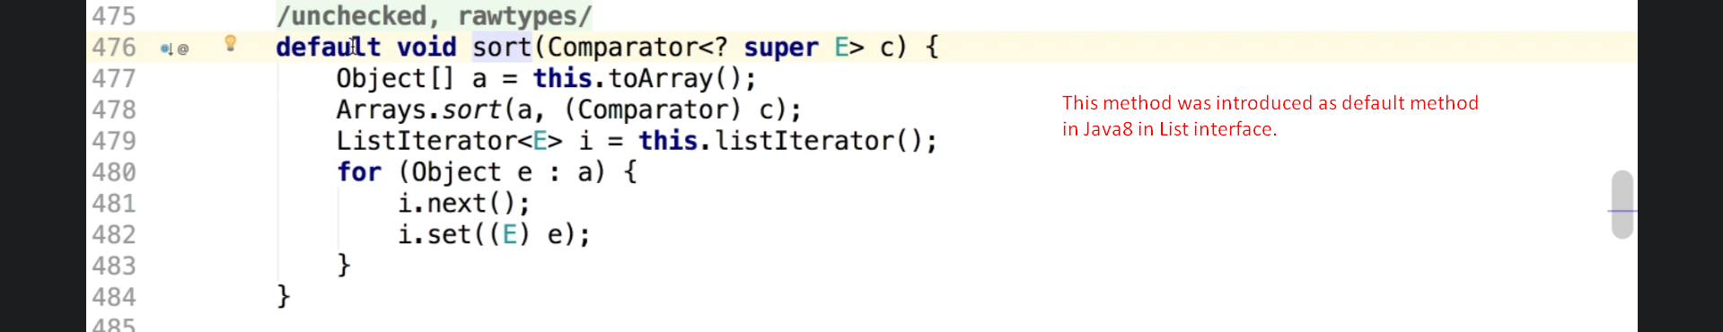
2. 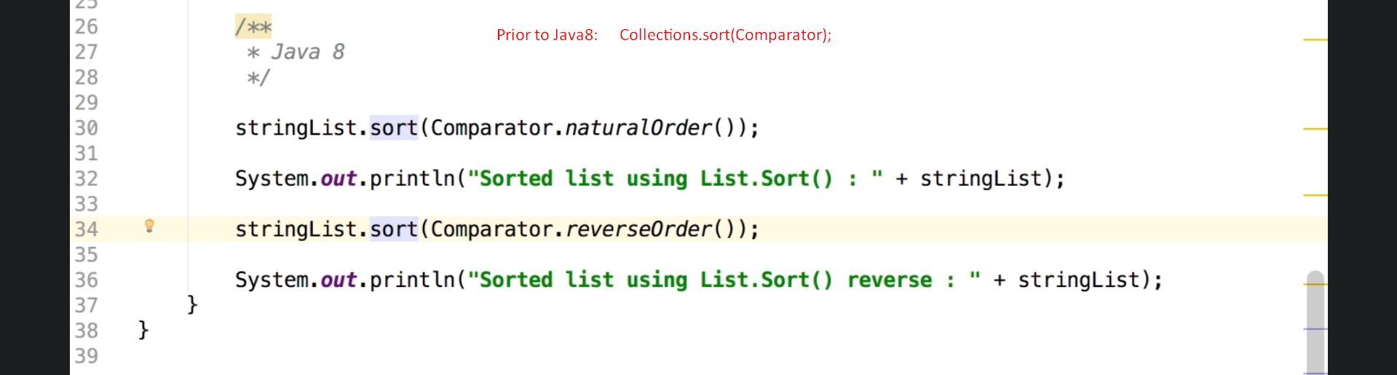
3. **NOTE**: There are three default methods introduced in List interface.